2.6-4)

a) Using MATLAB,

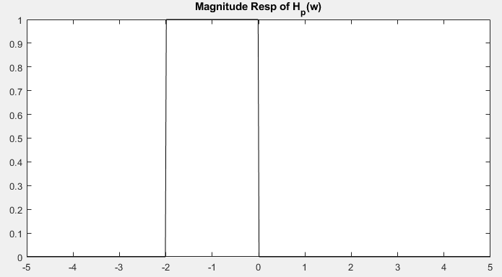

c) Lowpass-to-highpass with $ω_{0}=1 and w_{1}=2$

$$ω→\frac{ω_{0}ω_{1}}{-ω}=\frac{2}{-ω}$$

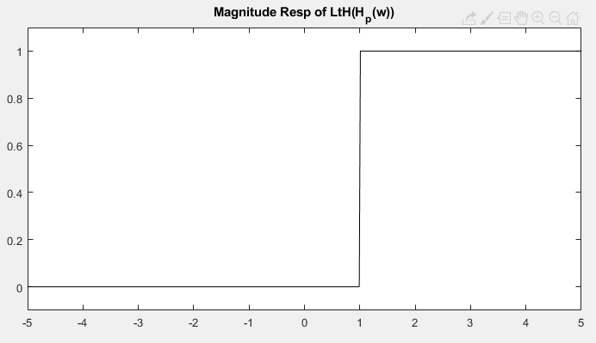

e) lowpass-to-bandstop with $ω_{0}=1 and w_{1}=2 and w_{2}=4$

$$ω→ω_{0}\left(\frac{ω(ω_{2}-ω_{1})}{-ω^{2}+ω_{1}ω_{2}}\right)=\frac{2ω}{-ω^{2}+8}$$

